Cannongate HOA, Report

Electroshocking Analysis Report Date Performed: February 28, 2022

Overview
On February 28, 2022 a fish population analysis was conducted using standard electrofishing procedures. Data collected during this study was analyzed to describe the current conditions of the fishery. Based on the data collected, management recommendations have been made to improve the fishery in order to reach your goals.
Water Quality
Water quality was below the required 20ppm that we would like to see. High numbers in this category allow for a more efficient fertilization, however, the lake can still have a good phytoplankton bloom to support the fishery just may not last as long. When these numbers are higher it helps balance the pH swing throughout the day so that the fish experience less stress.
Parameter | Recorded | Recommended
Alkalinity | 10 | >20
Hardness | 10 | >20
pH | 7.4 | 6.5-8

Electroshocking Data
The following figures provide information on the total number of fish sampled during the analysis, proportions of each size class in the sample, and the health of the fish in those size classes. Table 2. provides data showing how many bluegill, redear, and bass were captured in each size class. We were able to get a good snapshot of what the current condition of the lake and the dynamics currently going on.
Table 1: Data collected from the sampling event
Species | Size Class (in.) | Quantity
Bluegill | Reproduction (<3) | 0
Bluegill | 3-5 | 9
Bluegill | 5-7 | 23
Bluegill | 7-9 | 6
Bluegill | >9 | 4
Shellcraker | Reproduction (<3) | 0
Shellcraker | 3-5 | 0
Shellcraker | 5-7 | 0
Shellcraker | 7-9 | 0
Shellcraker | >9 | 0
Largemouth Bass | <4 | 3
Largemouth Bass | 4-8 | 4
Largemouth Bass | 8-10 | 25
Largemouth Bass | 10-12 | 23
Largemouth Bass | 12-14 | 3
Largemouth Bass | 14-16 | 1
Largemouth Bass | 16-18 | 0
Largemouth Bass | >18 | 5

Bluegill and Redear Overview
Overall, the bluegill population consisted of primarily larger bluegill of 5” or longer. We like to see bluegill populations that have more 3-5 and 5-7” fish as these are important to have as forage for bass as they grow. The crappie in there were large. This indicates that the bass numbers are high enough to reduce the crappie numbers so that those that survive that predation grow large and fast. It can also mean that residents are also pulling them out as well reducing their numbers. Crappie provide an additional competition to the bluegill and the bass. They eat the bluegill as well as the smaller zooplankton at a smaller size competing with both other species. This additional species makes reaching management goals a little trickier. The following figure shows the proportion of bluegill sampled in specific size classes.
Figure 1: The blue bars represent bluegill and the redline shows a balanced population trend.

Largemouth Bass Overview
The bass sampled were mostly in the 10-12” size classes (Figure 2). This trend is common in the ponds that have little forage available which limits the growth of the bass. This is also a repercussion of lack of bass harvest. Removal of bass helps reduce the competition among themselves and allows for a more diverse size representation in the lake with increased chances of catching healthy bass. You’ll see that there is potential for large bass in the lake. Some bass are able to take advantage of the situation and can grow to large healthy fish. The crappie as mentioned compete with the bass for the bluegill which aids in the stunting of the bass. Crappie have very sporadic spawning success and can have multiple failed years and easily have multiple successful years. There is just no way of predicting it which can further stunt bass and encourage things to get out of balance. In addition, removing those smaller bass reduces the predation on the crappie and will increase the quantity that the community could catch adding to that fishery.
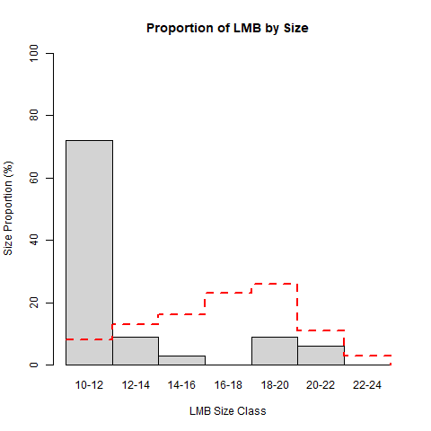
Figure 2: Above you can see what size class the majority of the fish that were weighed and measured during sampling fall in..

Relative weight was calculated for each individual fish as well as across size classes (Figure 3). You’ll see that the larger fish are much healthier than the smaller fish we sampled. The larger fish were females and capable of taking advantage of the forage that is predominately available in the lake. Female fish are the ones that you see reaching those double digits and even creeping on 10 lbs, but bass are also able to take advantage of forage 1/3 of its length. This allows them to have such higher relative weights. The 10-12” size bass also have a high relative weight than the 12-16” fish because they are able to benefit from the smaller forage that comes in during the summer after spawning and allows them to stay healthy. However, stunted bass can also range from age 3-8 so once stunted they may not be able to exhibit good growth rates. These size classes are also competing with the crappie for forage.
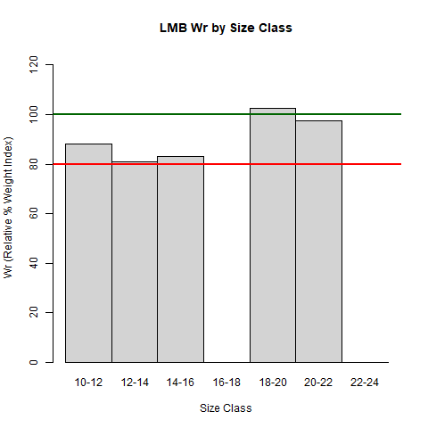
Figure 3: Relative weights is an accurate description of how your bass are doing not only in a size class format, but on an individual basis as well. The green line represents a healthy relative weight of 100% while the red line represents a skinny population of 80%.

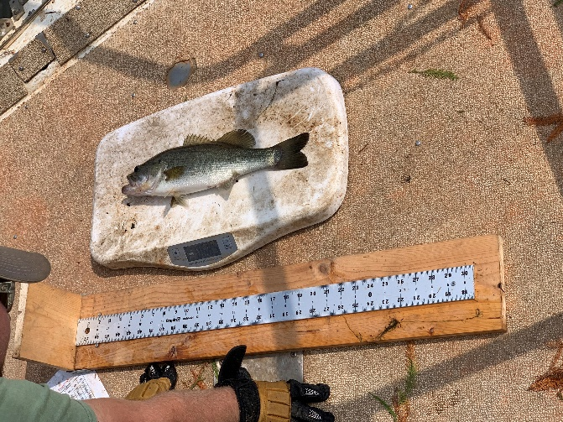We weighed and measured bass of 10” and longer and found:
- Average Length: 12.5”
- Average Weight: 1.2 lbs
- Average relative weight: 89%
- Weight Removed: ~13 lbs
This relative weight was biased by the larger fish. These females were also more than likely full of eggs. Water temperatures are increasing and getting closer to 60-65 and they have been eating all winter to be able to grow/develop eggs. Spring weights prior to spawning can bias results, but we were able to still see that there is an issue with available forage by shocking and collecting bluegill numbers and getting a good sample of bass. If we were able to sample again in the fall we could see how well the fish bounced back after spawning stress and summer stressors (heat/diseases). If the forage is adequate to number of bass present the relative would not change more than a percent or so.
Recommendations
The following recommendations are based off the data collected during the analysis. These recommendations are provided to help guide you to make choices that help you improve the fishery.

Harvest Strategy:
While residents may or may not be harvesting bass it should be pushed at the meeting so that the fishery can benefit from it. Pulling bass has become taboo due to the catch and release mentality and being told you have to let it go to let it go, unfortunately it’s the opposite. Removal of crappie isn’t necessary if residents enjoy catching them. As bass are pulled you will see more small crappie present in the lake as that pressure will be reduced. However, this will also increase food source competition for the bluegill, but the crappie will also predate more on the bass so it does get tricky. I suggest getting a feel for what the community wants before setting fishing regulations.
Forage Strategy:
We have already discussed adding in crawfish as an additional forage for the bass to help them grow. They are a great source of nutrients and can help filter out organic materials that come into the system. Additional bluegill should also be considered or threadfin shad. Shad will help eat the clumping blue-green algae in the lake and help alleviate the predation on the bluegill as they are a forage for both crappie and bass. Bluegill addition will help boost the population and put more bluegill into the system through reproduction. However, this should only be done if the community is will to pull the recommended weight of bass every year.
Water Quality:
Improvements on the water are needed but need to be performed during the winter time. We are still seeing a phytoplankton bloom become established, but adding in limestone should be considered if a tandem dump truck can get down to the boat ramp as well as our 24’ long barge.

Population Monitoring:
Adding a survey in every year will help keep track of the population and what is needed in the future. If the community doesn’t want to remove the bass themselves we can discuss a strategy that would allow for us to harvest the bass for you. However, some form of monitoring should be discussed to follow up on forage stocking and the progress of the bass.

Recommendation | Quantity | Price
Lime Application | 60-80 Tons | $85/ton
Continue Fertilization Program | 1-1 ½ gal/acr | Included in Management Plan
Bluegill (1-3”) | 15,000 | $280/1000 fish
Threadfin Shad | 3-4 loads | $1350/load
Crawfish | 25-50 lbs/acr | TBD
Harvest Bass | 25-30 lbs/acr
Population Survey | 1 every year

To prioritize what is most beneficial to the lake I would recommend amending the water and adding forage this year. We can put the limestone out from November into January/February and the fish/crayfish can be stocked this spring March/April or this fall September-October.

